INTRODUCTION TO DOCKER

- What is Docker?

Docker is a set of platform as a service (PaaS) products that use OS-level virtualization to deliver software in packages called containers.The service has both free and premium tiers. The software that hosts the containers is called Docker Engine.Docker is an open-source platform that allows developers and system administrators to automate the deployment of applications inside lightweight, portable containers.

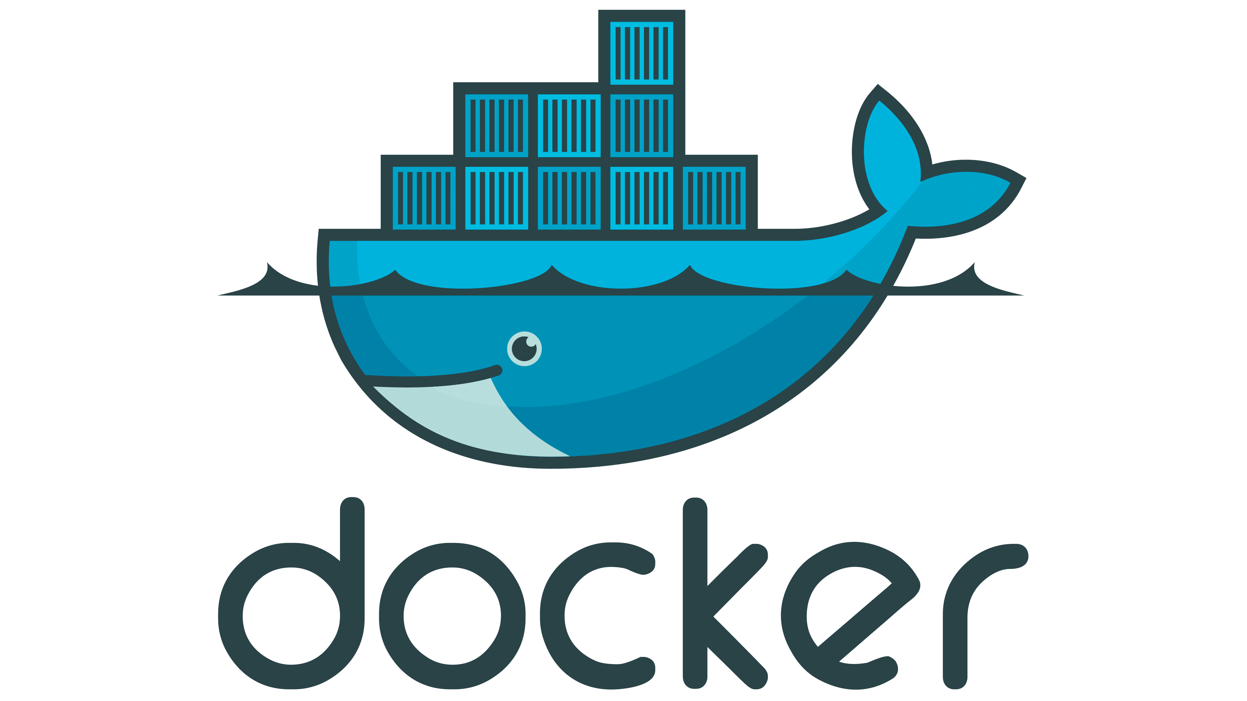

Why Use Docker? (With Docker vs Without Docker)

Without Docker:
- Developers install software manually.
- Apps may work on one system but fail on another.
- Need to configure environments each time.
- Hard to maintain multiple versions.

With Docker:
- One-time setup with Dockerfile.
- Container runs the same anywhere.
- Quick and consistent deployment.
- Easy to scale and test multiple versions.
- Key Benefits of Docker
Here are the main advantages of using Docker:
1. Lightweight
- Docker containers share the host OS kernel.
- They don’t need a full operating system inside.
- This makes them faster and smaller than traditional virtual machines (VMs).
2. Fast & Efficient
- Containers start in seconds.
- You can build, test, and deploy quickly.
- Developers save time on setup and debugging.
3. Isolated
- Each container runs in its own environment.
- One app can’t mess with another.
- Safe for running multiple apps on the same system.
4. Consistent
- Same configuration, same behavior.
- No more "It worked on my laptop" issues.
- Great for CI/CD pipelines and testing.
5. Reusable & Scalable
- Use existing images from Docker Hub (e.g., MySQL, Nginx).
- Easily scale apps by running more containers.
- Works perfectly with Kubernetes and DevOps tools.
- Docker Architecture:
Docker follows a client-server architecture where various components work together to simplify how software is built, shipped, and run across environments.
Docker breaks applications and their dependencies into lightweight, portable containers that run consistently on any system—local, staging, or production.
- Docker Engine is the core software component of Docker that allows you to build, run, and manage containers on your system.
It’s the heart of Docker, running in the background as a client-server application.
Key Components of Docker Architecture
The Docker architecture is mainly made up of the following parts:
- Docker Client
- Docker Daemon (dockerd)
- Docker Images
- Docker Containers
- Docker Registry
- Docker Objects (Networks, Volumes)

Docker Client
The Docker Client is the user interface for Docker. It is what developers use to interact with Docker via the command line interface (CLI) or tools like Docker Desktop.
- The command-line tool (docker) sends commands to the Docker Daemon using REST APIs.
- Common commands:
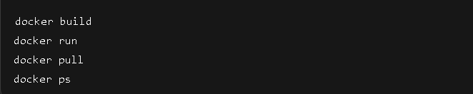
- The client can communicate with a local Docker Daemon or a remote daemon running on another machine.
- The client itself doesn’t do any container work—it simply sends instructions to the daemon.

- Docker Daemon (dockerd)
The Docker Daemon is the core engine that runs in the background and performs all tasks related to:
- Creating and managing Docker images
- Running and stopping containers
- Managing volumes, networks, and Docker objects
Main responsibilities:
- Listen to Docker API requests from the client.
- Handle container lifecycle: create, start, stop, destroy.
- Pull/push images from/to Docker registries.
- Build new images from Dockerfiles.
On Linux, the daemon runs as a system service. On Windows/macOS, it is bundled with Docker Desktop.

Dockerfile
A Dockerfile is a plain text file with step-by-step instructions to build a Docker image.
It tells Docker:
- What base image to use
- What files to copy
- What commands to run (install, build, start app)
Each line in a Dockerfile creates a layer in the image (helps with caching and faster builds).
Sample dockerfile:
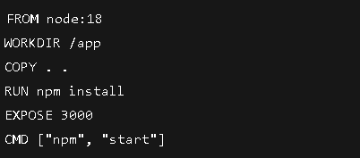

- Docker Image
A Docker image is a read-only template used to create containers.
- Images are built using Dockerfiles and can be:
- Downloaded from Docker Hub
- Shared with teams
- Version-controlled
- Each image is made up of layers that help with caching and faster builds.
- Example: An image might start with a base like node:20, and then install your app code on top.

Docker Containers
A Docker Container is a running instance of an image. Think of containers as virtual environments that are:
- Lightweight
- Isolated from the host OS
- Fast to start and stop
Containers share the same OS kernel but operate in their own user space, making them highly efficient compared to virtual machines.

Benefits:
- Start in milliseconds
- Use minimal system resources
- Can be easily removed and recreated
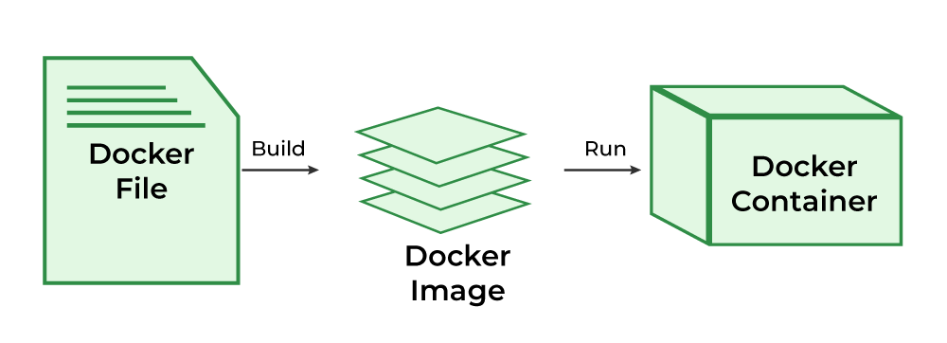

Docker Registry
A Docker Registry is a place to store and distribute images.
- The default public registry is Docker Hub.
- Docker Hub is a cloud-based registry service provided by Docker that allows you to find, share, store, and manage container images. Think of it like the "GitHub for Docker images."
- You can also create private registries (self-hosted or using services like AWS ECR or Azure Container Registry).
- Registries help teams:
- Store multiple versions of an app
- Share custom-built images
- Automate CI/CD workflows

Docker Objects (Networks, Volumes, etc.)
Docker also uses other important objects:

Networks
- Allow containers to communicate with each other
- Default types: bridge, host, none, overlay

Volumes
- Used for persistent data storage outside containe
- Very useful for databases and file storage

How They All Work Together
Here's a simplified workflow of Docker Architecture in action:

Workflow:
- Developer runs a Docker command via Docker Client
- The command is sent to the Docker Daemon
- The Daemon:
- Pulls the image (if not present)
- Builds the image (if needed)
- Creates and runs the container
- Containers use volumes and networks as needed
- The image can be pushed to/pulled from a Docker Registry

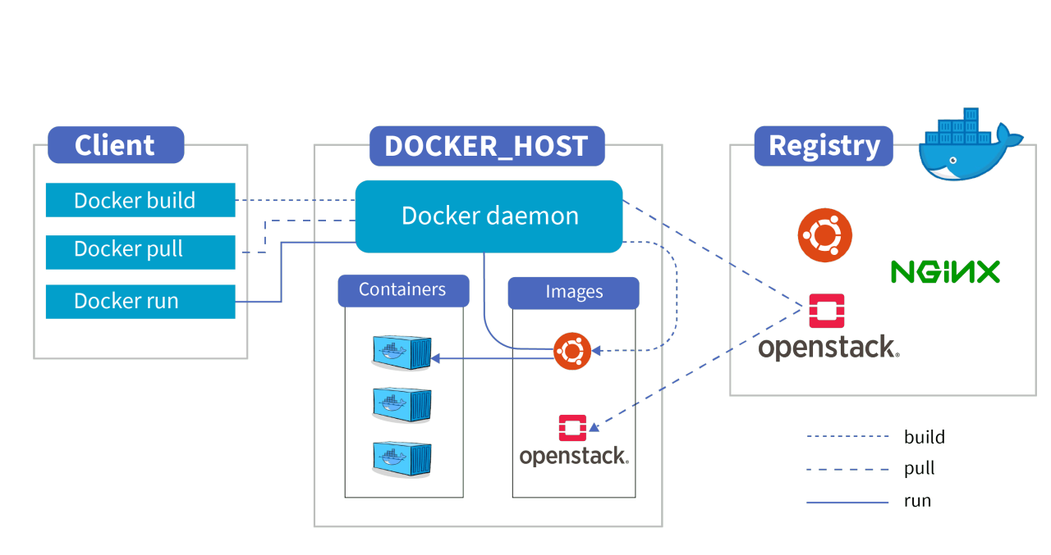
- Installing Docker
To get started with Docker, you need to install Docker Desktop, which includes:
- Docker Engine
- Docker CLI
- Docker Compose
- Docker Daemon
It is available for Windows, macOS, and Linux.

Steps to Install:
- Go to Docker Desktop for Windows.
- Click Download for Windows.

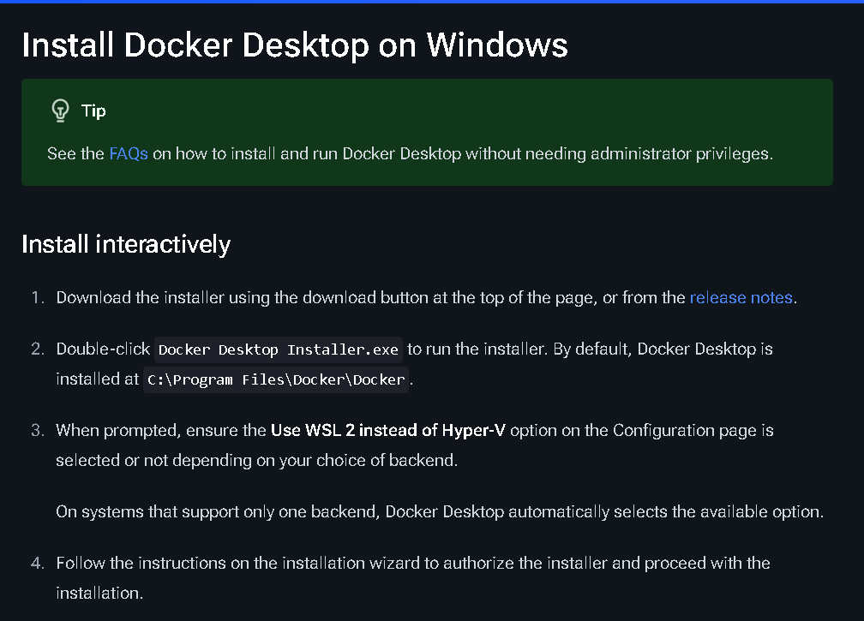
- Go to release note-->click on Windows-->docker desktop will download
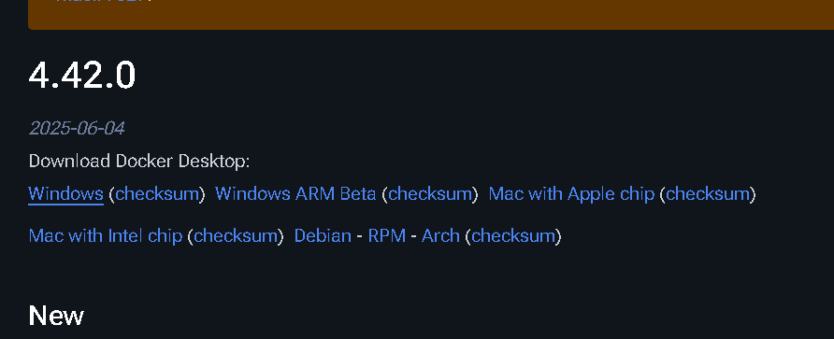
- Run the .exe installer after download.
- Follow the setup wizard.
- After installation, restart your computer if required.
- Open Docker Desktop from Start Menu.
- You can now use Docker CLI in PowerShell or WSL Terminal.
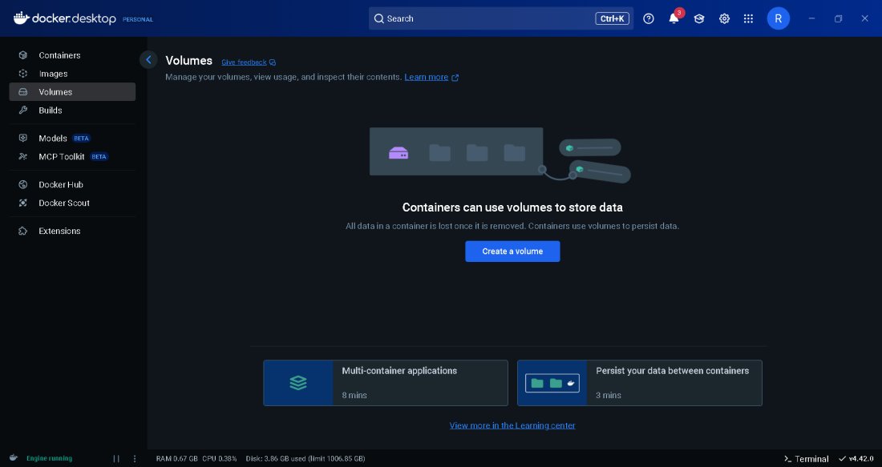
- Our docker is ready if it show the engine running.
- Create a DockerHub Account in https://hub.docker.com/

Basic Docker Commands
Docker provides a powerful command-line interface (CLI) that helps you manage containers, images, volumes, networks, and more.
Let’s go through some essential Docker commands every beginner should know:
- docker --version:
- Purpose: To check the installed Docker version.
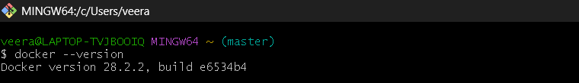
- docker pull <image> :
- Purpose: To pull the latest image from DockerHub to Docker Desktop and it is stored in images.
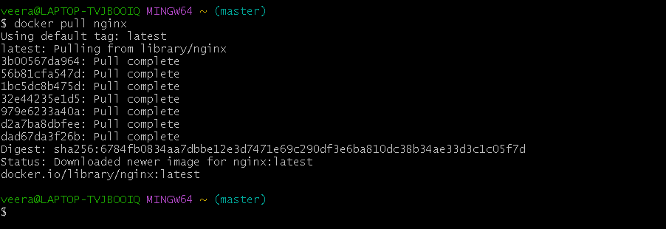
- Docker images :
- Purpose: list all the images in the docker desktop.
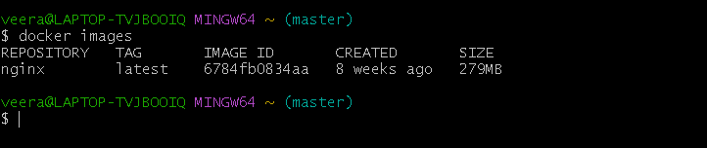

- Docker run -d --name <containername> -p <exposedport> <image>:latest
- Purpose: In background it run the image and create a container.
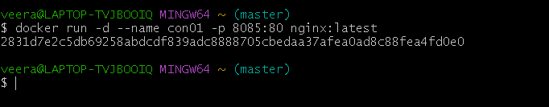
- After successfully running the Docker container, we need to map the container port to a port on the host system. This allows us to access the application in a web browser like Chrome.
- http://localhost:8085
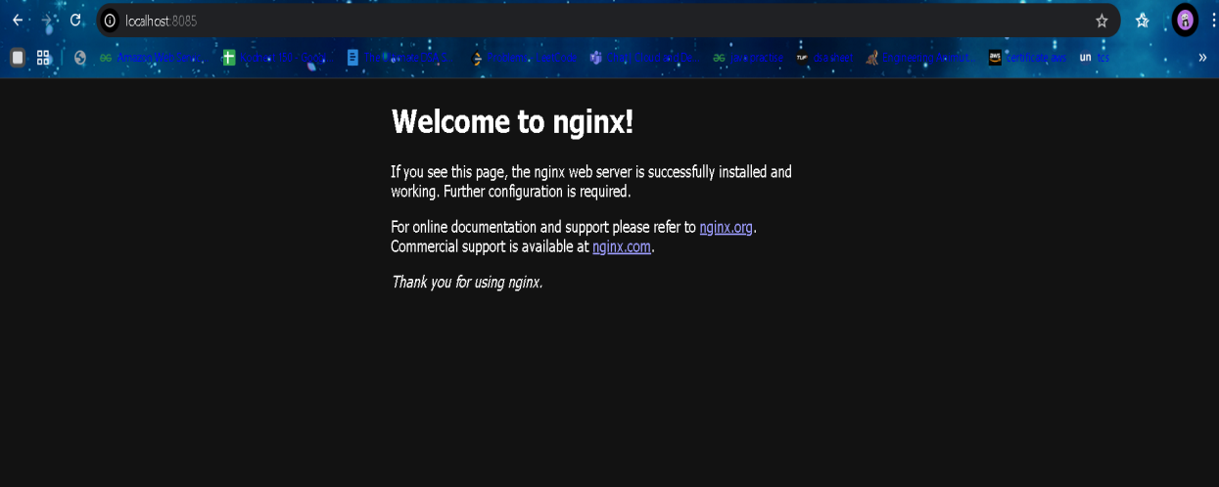
- Docker ps:
- Purpose: To view all running containers.
- Docker ps -a:
- Purpose: To view all containers including stopped ones also.
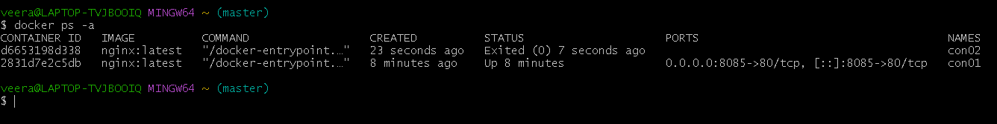

- Docker stop <containerID/conatinerName> :
- Purpose: To stop the container.
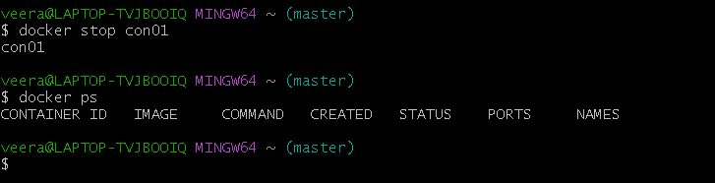
- Docker rm <containerID> :
- Purpose: To remove the container.
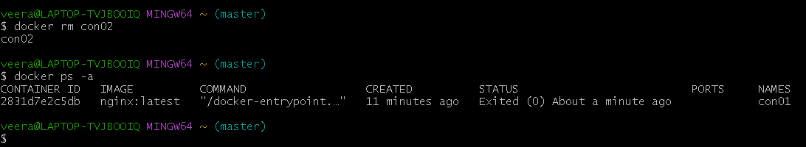
- Docker rmi <imagename> :
- Purpose: To remove the image.
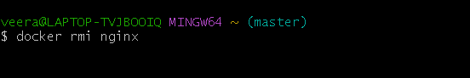
- Docker build -t <name>:latest . :
- Purpose: To create the image from docker file.

Docker Volume (Storage)

Docker Volume is used to store data generated and used by Docker containers. It helps persist data even if the container is stopped or deleted.
Why it's needed:
- By default, when a container is removed, all its data is lost.
- Volumes let you save that data permanently and share it between containers.
- Ex:
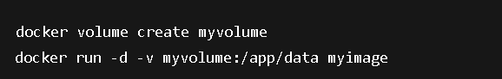

Docker Compose (Multi-container Setup)

Docker Compose is a tool for defining and running multi-container Docker applications using a simple docker-compose.yml file.
Why it's needed:
- Instead of running many docker run commands manually, use one file to define all services (e.g., web server + database) and run them with a single command.

Docker Swarm (Clustering/Orchestration)
Docker Swarm is Docker’s built-in tool for container orchestration — managing multiple containers across multiple machines (nodes) as a single cluster.
Why it's needed:
- Useful in production where you want high availability, scaling, and load balancing.
- Automatically handles scheduling, failover, and service discovery.
How it works:
- You create a Swarm cluster with one or more manager nodes and worker nodes.
- Then deploy services that run on any of the nodes.
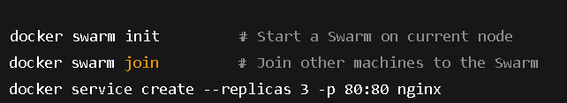

- Task-1: Clone and Run a To-Do List Application Using Docker:
In this task, we containerize a simple To-Do List web application using Docker. We perform the full Docker workflow — from cloning the code to viewing the app in the browser.
Before starting the actual process, it's important to understand the workflow we follow using Docker. All the steps are executed using Docker CLI commands. Here’s a clear breakdown of the process:
- Clone the project from a GitHub repository to your local system.
- Create a Dockerfile inside the project folder, which defines the instructions to build the Docker image.
- Build the Docker image using the docker build command.
- Once the image is created, push the image to Docker Hub so it can be shared or used on any system.
- You can also pull the image from Docker Hub to your local Docker Desktop when needed.
- Run the image, which creates a container.
- After running the container and mapping the ports, you can access the output in your browser or terminal.
Step 1: Clone the GitHub Repository
- Git clone <repoURL>
- Cd <projectfolder>
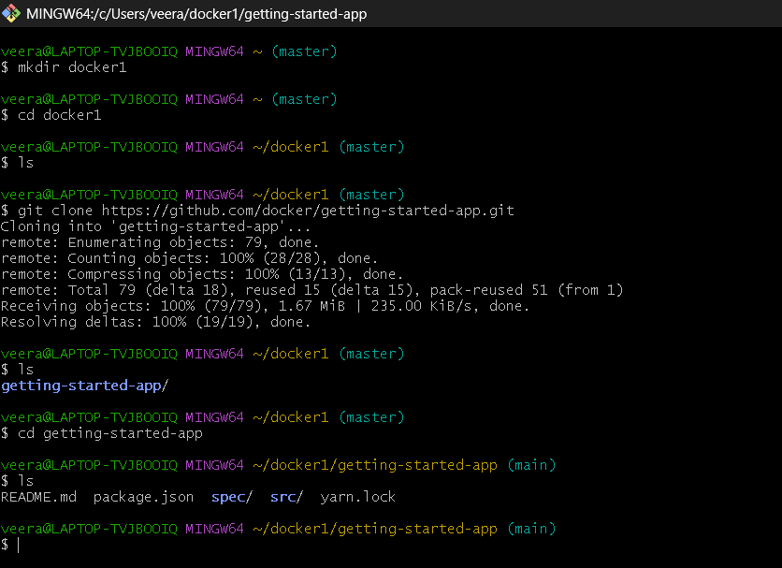

Step 2: Create a Dockerfile
Inside the project directory, create a file named Dockerfile with the required instructions to build the Docker image.
- Touch Dockerfile
- Vi Dockerfile
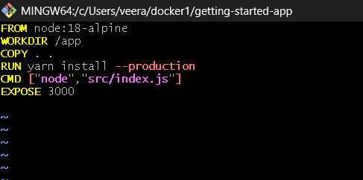

Explanation of Each Line

FROM node:18
- This sets the base image.
- It tells Docker to use an official Node.js version 18 image as the starting point.
- It already contains Node.js and npm installed.

WORKDIR /app
- Sets the working directory inside the container to /app.
- All the following commands will run from this location.
- It’s like doing cd /app inside the container.

COPY package*.json ./
- Copies package.json and package-lock.json into the container’s /app folder.
- Using a wildcard (*) ensures both files are copied.
- This is done before copying the full source code to take advantage of Docker layer caching (faster builds).

RUN npm install
- Runs npm install to install all Node.js dependencies.
- This is run inside the container in the /app directory.

COPY . .
- Copies the entire project (all files from your local folder) into the container’s /app directory.
- The first . = current local directory.
- The second . = target inside the container (i.e., /app due to WORKDIR).

EXPOSE 3000
- Tells Docker that the application will listen on port 3000 inside the container.
- This does not actually open the port; it just acts as documentation and allows tools to read it.
- You’ll still map it to a host port with -p when running.

CMD ["npm", "start"]
- This defines the default command to run when the container starts.
- In this case, it tells Docker to run npm start, which usually starts the server.
- CMD uses JSON array syntax here, which is more reliable across platforms.

Step 3. Build the Docker Image
Run this command to build your Docker image:
- Docker build -t <name>:latest .
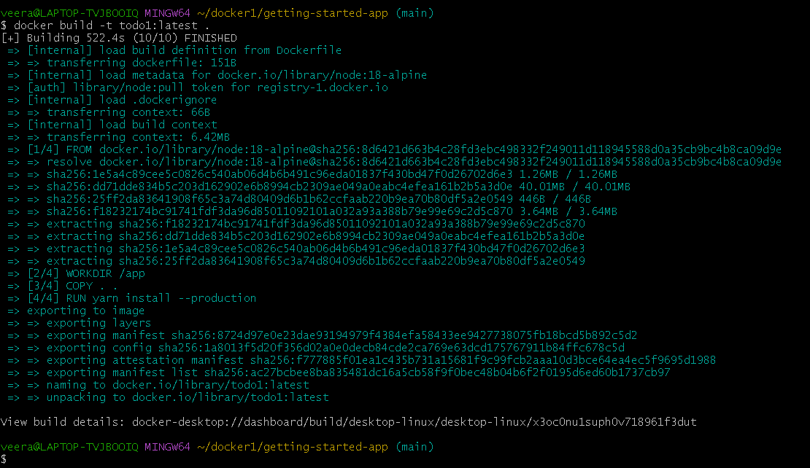

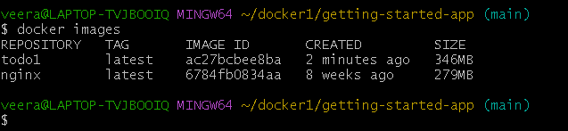

Step 4: Push the Image to Docker Hub
If you want to share the image, push it to Docker Hub.
- Before pushing the image we need to create a repository in the docker Hub.
- We need to Tag the image and push the image to the DockerHub.
- Docker tag <imagename>:latest <tagrepo>:latest
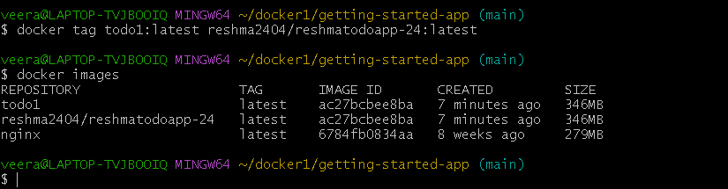
- Connect to the docker hub
- Docker login
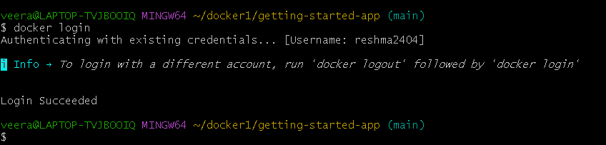
- Docker push <tagrepo>:latest
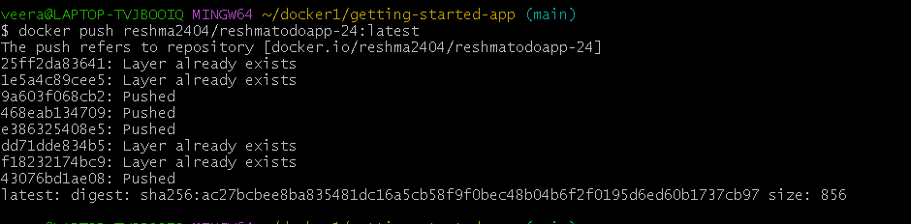

Step 5: Run the Image (Create a Container)
Now, run the container and map the internal app port to a host port (e.g., 8080):
- Docker run -d --name <containername> -p <exposeport> <image>:latest

Step 6: Access the Application in Chrome
Open your browser and go to:
- http://localhost:3000
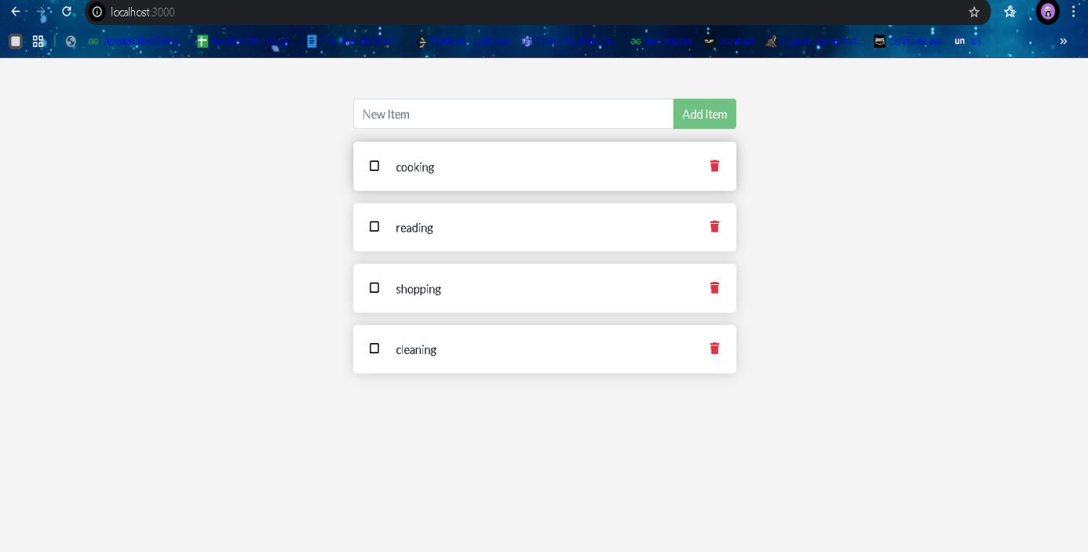

- Task-2: Clone, Dockerize, and Run a .NET Application
The process we follow for Dockerizing the .NET Core application is almost the same as the To-Do List app we did earlier. The steps — cloning the code, writing a Dockerfile, building the image, pushing it to Docker Hub, running the container, and accessing the output in the browser — remain the same.
The only difference is that here we are working with a .NET-based application instead of a Node.js-based one.

Steps:
- Git clone <repoURL>
- Cd <projectfolder>
- Vi Dockerfile
- Docker build -t <name>:latest .
- Docker run -d --name <containername> -p <exposeport> <image>:latest
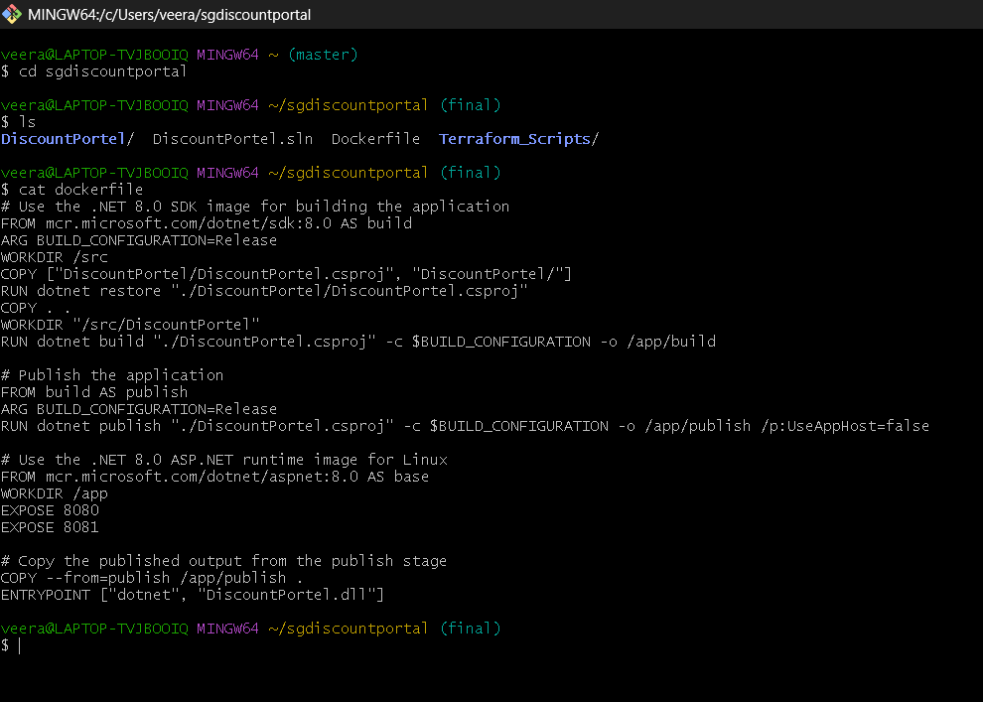
- Output in the browser (http://localhost:<port>/swagger)
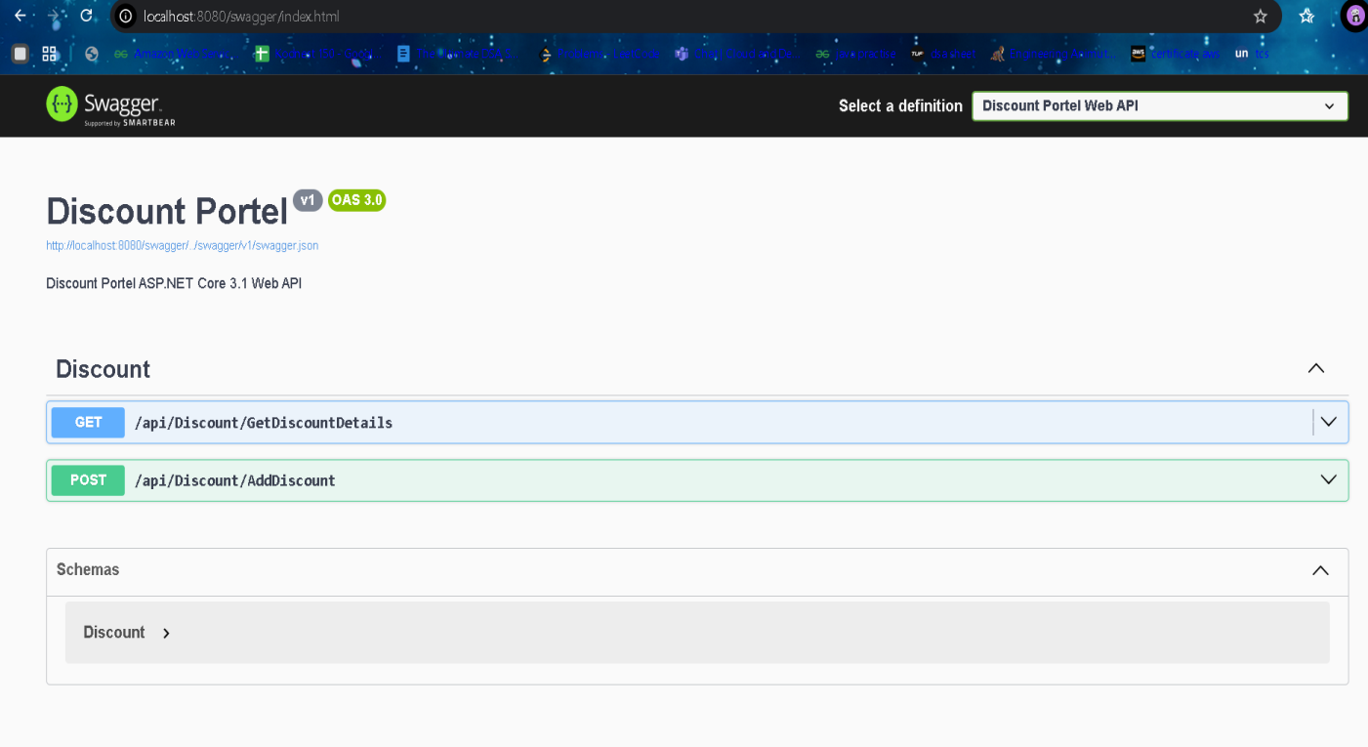
Conclusion:
This task proves that the Docker workflow remains the same regardless of the technology stack. Whether we use a Node.js application (like the To-Do List) or a .NET Core application, the process of containerization, image building, and running the app inside a container is consistent and reusable.

- Step-by-Step: Build and Push Docker Image to Docker Hub using Azure DevOps Classic Editor.
Using Azure DevOps,We need to build the dockerfile and push the image to the Docker Hub for that we need to make a connection between the Azure DevOps and Docker Hub.

Step 1: Prerequisites
Make sure you have:
- A Dockerfile in your repository
- A Docker Hub account
- An Azure DevOps project
- Code stored in Azure Repos, GitHub, or other supported source.

Step 2: Create Docker Hub Service Connection
- Go to your Azure DevOps Project.
- Click Project settings (bottom-left).
- Go to Service connections > click New service connection.
- Choose Docker Registry, then click Next.
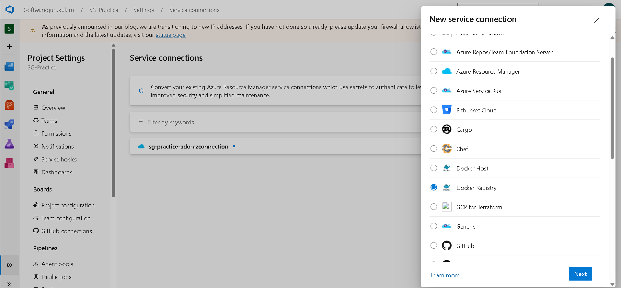
- In the dialog:
- Registry type: Docker Hub
- Docker ID: your Docker Hub username
- Password/Token: your Docker Hub password or access token
- Registry URL: https://index.docker.io/v1/
- Name it something like dockerhub-service and click Verify and Save.
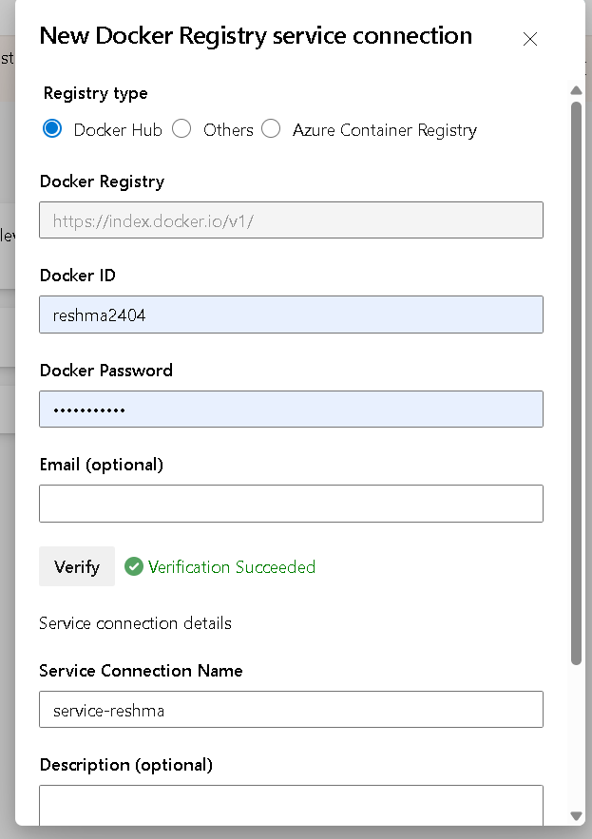

Step 3: Create Classic Build Pipeline
- Go to Pipelines > Builds in Azure DevOps.
- Click New Pipeline.
- Select your code repository (e.g., Azure Repos Git, GitHub).
- Choose "Use the Classic Editor".
- Select your branch (usually main) and click Continue.
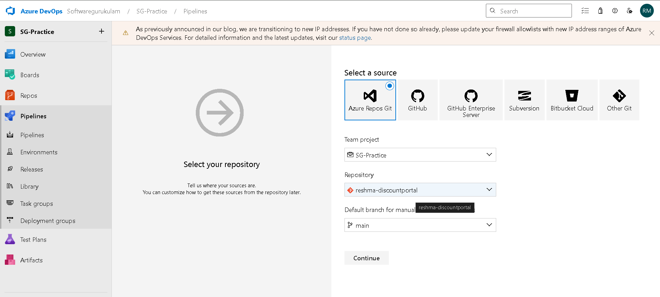
- Choose Empty Job.

Step 4: Configure Build Pipeline
- Rename the pipeline (e.g., Build and Push Docker Image).
- Agent pool: Use Azure Pipelines
- Agent Specification: ubuntu-latest
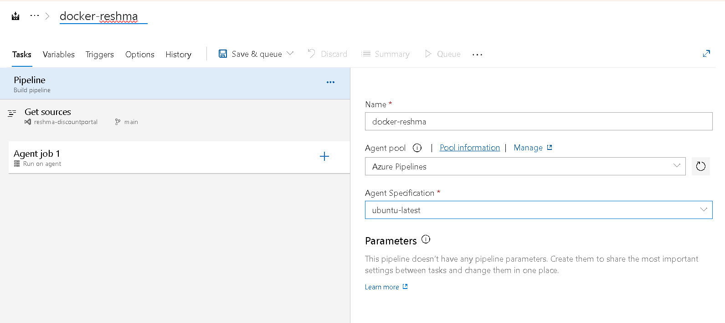

Step 5: Add Docker Build and Push Tasks
- Add Docker CLI Installer

Task 1: Docker (Build Image)
- Click + on the agent job.
- Search for Docker and add the Docker task.
- Set:
      - Container Registry Type: Container Registry
      - Docker Registry Service Connection: dockerhub-service (what you created earlier)
      - Command: build
      - Dockerfile: Path to your Dockerfile (e.g., Dockerfile)
      - Repository: yourdockerhubusername/yourimagename
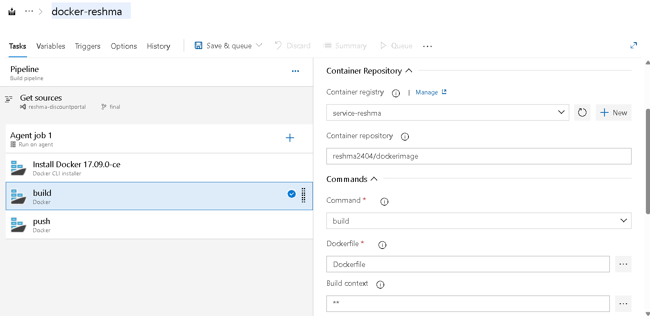

Task 2: Docker (Push Image)
- Add another Docker task.
- Set:
      - Container Registry Type: Container Registry
      - Docker Registry Service Connection: dockerhub-service
      - Command: push
      - Repository: Same as before (e.g., yourdockerhubusername/yourimagename)
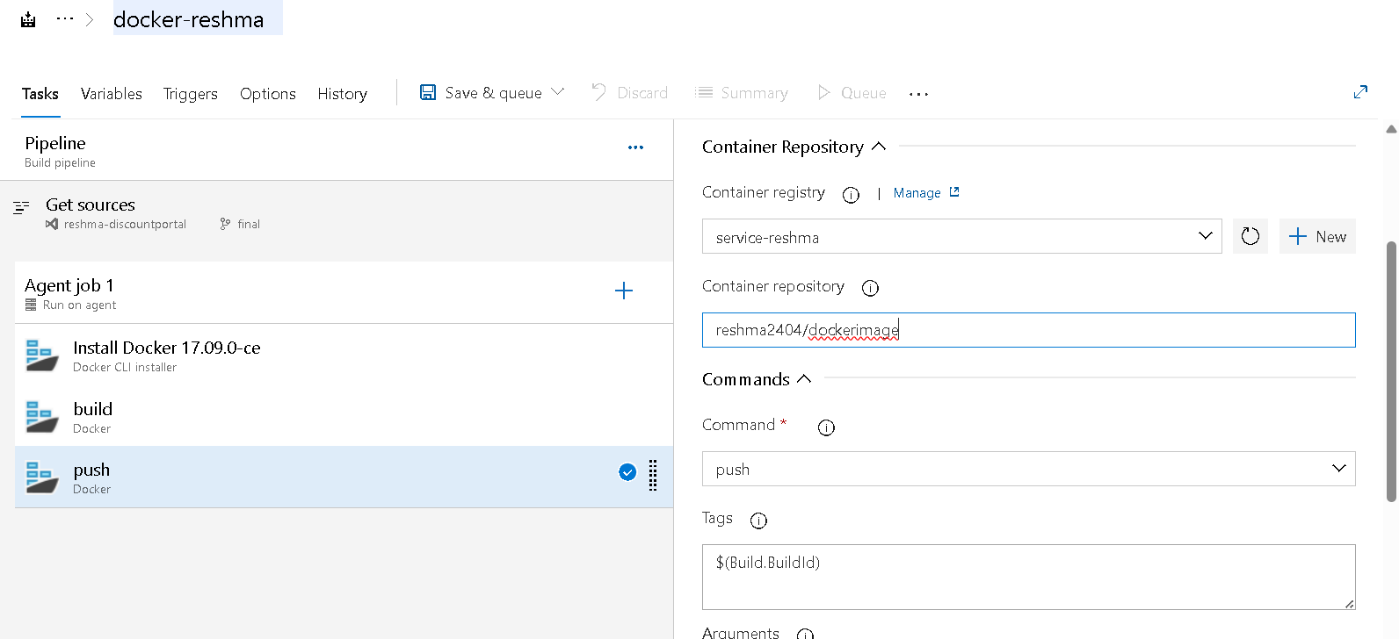

Step 6: Save and Run
- Click Save & Queue > Save & Run.
- Choose your branch and click Run.
Azure DevOps will:
- Build the Docker image using your Dockerfile
- Push the image to your Docker Hub repository
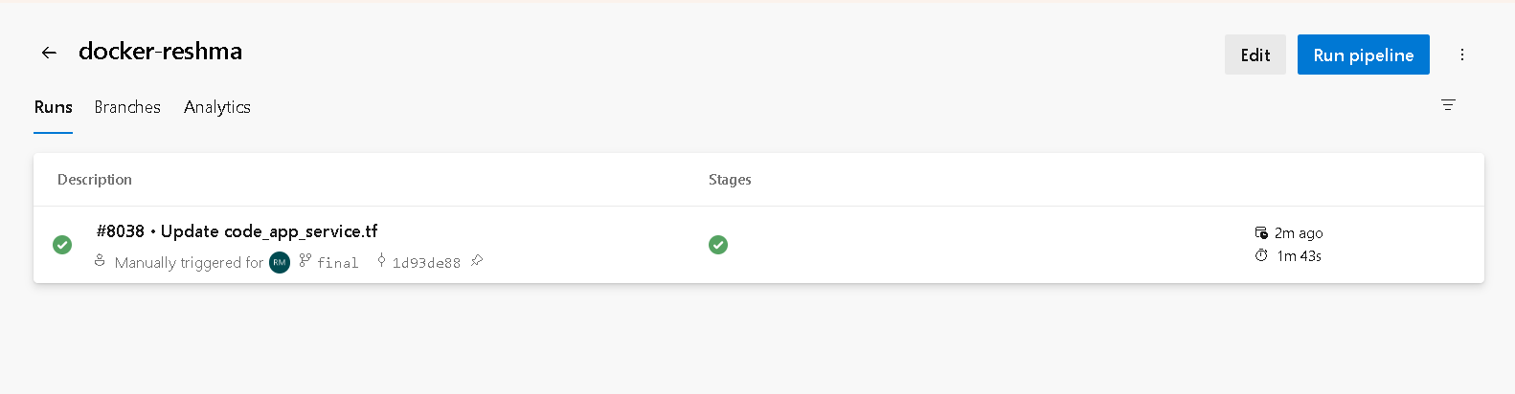

Result
After the pipeline succeeds:
- Go to Docker Hub
- Check if your image (yourdockerhubusername/yourimagename:latest) is listed
